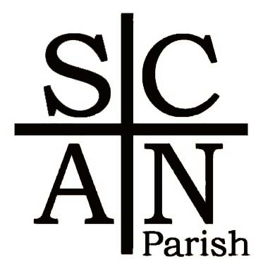

‘Our vision is to be a growing church which, by God’s grace, serves the whole community’

SCAN Parish

Annual Report

Year ended 31 December 2022

www.scanparish.co.uk

Election of Synod, PCC and DCC members, according to motions passed at 2003 APCM

- The PCC shall consist of 6 Churchwardens and 3 Synod representatives, plus 2 other representatives from each Church to be elected at the AGM. These will include the 3 treasurers (who must be elected at the AGM) and the PCC treasurer (who may be elected separately from any of the churches).
- Church Committee secretaries who are not elected PCC members should be co-opted onto the PCC.
- Each church will also elect up to 6 additional members of their District Church Councils (DCC).
- Each DCC will consist of 2 Churchwardens and the PCC members, any Synod members who are members of the Church in Question and the elected DCC members plus PCC co-options.
- DCCs to co-opt up to 2 members: the PCC can co-opt up to 4.

Minutes of the Annual Vestry Meeting
of the SCAN Parochial Church Council
Held on Sunday 15th May 2022

The meeting commenced with an opening prayer led by Rev Coralie Mansfield.

Present: Rev Coralie Mansfield, Rev Pam Fielding, Prof John Fielding, David Blamires,

Judith Duncombe, Tim Edwards, Nick Freeman, Janice Freeman, Christine Girard, Richard

Morgan, Malcolm Rose, Pat Townsend, Ian Townsend, Felicity Robertson, David Robertson

Jill Burgess, Trisha Clementson, Ted Pepper, Sue Harrington Robert Brewis, Anna Shotton

1 Apologies: Alan and Judy Plater, Sheila Quinn, Mark Vale.

2 Appointment of Chairman and Clerk: Rev Coralie Mansfield was appointed to be the

Chairman of the meeting and Malcolm Rose appointed clerk to take the minutes.

Proposed by Judith Duncombe and seconded by Pam Fielding - All were in favour.

3 Minutes of the last meeting: The minutes of the previous Annual Vestry Meeting held on

Sunday 25th May 2021 had been circulated. The minutes were approved and accepted.

Proposed by . Judith Duncombe and seconded by Pam Fielding. All were in favour.

4 Election of Churchwardens: The following persons were elected

St. Lawrence Chicheley:

David Robertson proposed by David Blamies seconded by Pat Townsend

Judith Duncombe proposed by David Robertson and seconded by David Blamires

St Lauds Sherrington:

Edward Pepper proposed by Tim Edwards and seconded by Richard Morgan

Richard Morgan proposed by Edward pepper and seconded by Sheila Quinn

St Firmins North Crawley

Malcolm Rose proposed by Kerry Rose and seconded by Audrey Anstee.

Janice Freeman proposed by Joan Shaw and seconded by John Plummer

5.Any other business

Judith Duncan proposed that the PCC structure should be amended to reflect the current

structure of scan parish so the PCC should consist of 6 churchwardens rather than the

current 8 and that there should be 3 DCC treasurer rather than the current 4

This was seconded by Tim Edwards

The Annual Vestry Meeting was then concluded.

Minutes of the Annual General Meeting
of the SCAN Parochial Church Council
Held on Sunday 15th May 2022
Present: Rev Coralie Mansfield, Rev Pam Fielding, Prof John Fielding, Action
David Blamires, Judith Duncombe, Tim Edwards, Nick Freeman, Janice
Freeman, Christine Girard, Richard Morgan, Malcolm Rose, Pat
Townsend, Ian Townsend, Felicity Robertson, David Robertson Jill
Burgess, Trisha Clementson, Ted Pepper, Sue Harrington Robert Brewis,
Anna Shotton

1 Apologies: Alan and Judy Plater, Sheila Quinn, Mark Vale.

2 Minutes of the last AGM: The minutes of the previous Annual Parochial
Church Meeting held on Sunday 25th May 2021 had been circulated. The
minutes were approved and accepted.
Proposed by Nick Freeman and Seconded by Judith Duncombe. All were
in favour.

3 Matters arising:
Item 12.21 John Fielding asked if there has been any progress on the
sale of Astwood church. Coralie reported that the items to be removed
had been agreed and the Diocese was in discussion with Astwood Village
hall committee for the war memorial to be moved to the village hall.
John Durden has the key and is aware of the items which will be
removed.
Coralie outlined that once the church has been told there will no longer be
the capacity for any more burials or interments and that PCC resolution
was required.
PCC resolution: no more burials or interment of ashes should take place
at St Peter’s church Astwood once the sale of the church building has
been completed
Proposed by Rev Coralie Mansfield seconded by Richard Morgan
All were in favour
Action Archdeacon guy will require a copy of this resolution

There were several questions:
Felicity Robertson asked if access to graves and monuments would be
allowed and Coralie confirmed that there was to be a deed of covenant in
the sale so that this could still take place with permission of the owner.
Judith Duncombe asked if there would be any obligation on the PCC for Rev CM to
public liability insurance and this will need to be discussed with the discuss with
Diocese Diocese
Pam Fielding asked if the Parish Council in Astwood is aware that burials
and interment of ashes won’t be allowed and suggested that it should be
circulated
Christine Gerard suggested this put in the scan parish magazine and
David Robertson suggested that any item placed in scan in respect of this
should be approved or possibly even drafted by the diocese.

Item 3.4 Administrator - Coralie confirmed that Jan Weatherly had
resigned in December due to ill health after being a Parish Administrator
for 12 years and felt that the PCC should send a gift of flowers to Jan in
acknowledgement for the work she had completed during this time.
Pam Fielding proposed that an arrangement of flowers be sent to Jan this Revd CM and
was seconded by Coralie and all were in favour. MR to arrange
Coralie will circulate a card for people to sign and Malcolm will arrange for
flowers to the value of £35 to be sent.

Coralie was pleased to report that our new administrator is Anna Shotton
and Anna was introduced to the members present.
The PCC will be using Anna on a self-employed basis and she will work
closely with Coralie and Pam in addition she will attend PCC meetings
and may attend one DCC meeting for each village so that she is aware of
how the parish operates.
Meeting has been arranged with Coralie and Anna to discuss
requirements on Tuesday 17th of May

4 Accounts for 2021: The PCC and DCC accounts for 2021 have been
circulated with the annual report. There were no questions on the PCC
accounts and it was proposed by Pat Townsend and seconded by David
Robertson that the accounts be received and agreed with all in favour. A
vote of thanks to David Blamires for his work in connection with the
accounts was made.
Tim raised that he felt it was important for the parish to try to pay the
parish share in full he felt that if this was not done then as a result the
diocese may not allocate scan in new priest when there was a change at
some point in the future
He felt it was important for the parish to have a plan which was put
forward to the diocese to outline how scan would work towards paying
the parish share in full it was agreed that this would go onto the agenda
of the next PCC meeting
Richard Morgan outlined that St Lauds did not manage to pay the parish
share last year it will be unable to pay the parish share in full this year.
In addition approx. 50% of scan parish share is allocated to St Lauds and
he felt that this was not sustainable for the future and should be looked at Agenda Item PCC
Pat outlined this was historic and allocation had be reached by including a
number of different elements but suggested a treasurers meeting to Treasurers
discuss meeting TBA
It was noted that there were no accounts in the annual report from St
Lauds or gift aid claimed Richard outlined how this had been due to
illness but with a new treasurer in place this was now in hand

5 Appointment of Auditor: It was proposed by David Blamires and
seconded by Nick Freeman that Alan Simms be appointed auditor for
2022. This was carried unanimously.
However it was noted that he had not been asked so David Blamires DB speak to
agreed to approach. Alan Simms

6 Annual reports: The Annual PCC Report had been circulated
previously the omission of Sherington accounts was noted but this had
been raised earlier in the meeting. All the reports were accepted.
Tim asked why the annual report had not been placed on the website and
asked how it had been circulated Malcolm reported that due to annual
reports from contributors not being made available until 14th of May
which was last Thursday there was limited availability to circulate but it
had gone by e mail to PCC and DCC members
It was agreed that for next year contributors should start to put their report
together from the 1st of January and forward to our administrator so that
the report could be put together in good time and posted on the website.

7 Election of PCC and DCC Treasurers:
PCC Treasurer: David Blamires
Proposed by David Robertson, seconded by Ian Townsend with all in
favour.
DCC Treasurers: St Lawrence - Pat Townsend
St Lauds – Nigel Anderson
St Firmins – Malcolm Rose

Proposed by Christine Girard, seconded by Nick Freeman all in favour.

8 Election of PCC members: Nick Freeman, Ian Townsend (PSGO) and
Pat Townend were proposed by Coralie Mansfield and seconded by
David Blamires with all in favour.
Remaining members of the PCC are ex officio.

9 Election of DCC members:
St Lawrence, Chicheley:
Christine Girard, Alan Plater, Felicity Robertson, Robert Ruck-Keene and
Pat Townsend.
St Laud, Sherington:
Robert Brewis, Sue Harrington, and Sheila Quinn, Nigel Anderson, Ann
Bond
St Firmin, North Crawley:
Nick Freeman, Ann Kearney, Pam Pinder, John Plummer, Joan Shaw,
All DCC nominations were proposed and seconded by electoral roll
members. All at meeting in favour
(Remaining members of the DCCs are ex officio or PCC members)

10 Electoral Roll: Following a review of the electoral roll the figures were as
follows:
Sherington: 37; Chicheley: 19; North Crawley: 15;
The revised rolls will be displayed on the doors of the individual churches
for 14 days.

11 Election of Officers: Deanery Synod:
Representatives to the Deanery Synod are due to be re-elected in 2024

12.Any Other business:
12.1 Deanery reorganisation:
Coralie outlined how she would like SCAN parishioners attend a
collaborative informal discussion with members of Newport Pagnell
church before the Deanery open meeting on the 31st of May and would
like as many as possible to go along.

Rev Nick Evans had suggested this informal chat and Coralie agreed she
would organise this if possible for Tuesday, the 17th of May

Tim outlined the progress of the deanery organisation highlighting that the
area dean had been off with Long Covid and was now on a phased return
but his Parish of Hanslope and Castlethorpe felt unable to progress
discussions in his absence. There had also been very little input from
Olney parish
Given all of this the deanery pastoral subcommittee had felt it
inappropriate to make a formal proposal at this time.
At the open meeting the Archdeacon will outline where we are with
progress and particularly the financial impact where the deanery is now
bottom of the league table for payment of Parish share within the Diocese
of Oxford.
Maggie Metaliaj. Pastoral Secretary for the diocese will also attend to
outline the legal process of the deanery reorganisation.
Some churches are considering becoming festival churches. In these
circumstances the upkeep of the church transfers to the wider community
but the parish no longer contributes to the deanery through Parish share.
This was a route was taken by the Lincoln Diocese some years ago and
they’re now suffering the consequences through lack of income.
It is also an acknowledgement that in parishes with festival churches the
attendance becomes worse without the presence of clergy.
Another route available is for greater collaboration of resources across
parishes and some have already started to discuss this.
John Fielding suggested he also talked to Haversham rather than just
Newport Pagnell.
Judith Duncombe Highlighted there were a number of options to consider
not just and amalgamation with Newport Pagnell
Tim confirmed this was the case no decisions had been made at this
stage.

12.2
David Robertson outlined that SCAN magazine had originated from a
previous rectors wife and really been started to share news and details of
fund raising events
There were some fundraising events that were no longer shared in scan
along with news from villages in particular North Crawley and Sherrington
David wanted to remind everybody that it was a missed opportunity if they
were not using scan in this way and encouraged Church reports from all
of the villages

13 Date of next meetings:
APCM: 16 th April 2023 at St Lauds Sherington
PCC: 14 th June 2022 at Village Hall Chicheley 7:30.

The meeting was then closed with the Grace.

.

Annual Report of the Parochial Church Council (PCC) of the United Benefice of SCAN PARISH (Sherington with Chicheley, North Crawley, Astwood and Hardmead) for 2022

Background

SCAN P.C.C is made up of three active churches, along with Hardmead, which is redundant and Astwood which is officially closed and the Diocese of Oxford is now responsible for its future use.
The PCC is responsible for working with the incumbent, in promoting within the parish the whole mission of the church - pastoral, social and ecumenical.

‘Our vision is to be a growing church which, by God’s grace, serves the whole community’

Incumbent: Revd. Coralie Mansfield

Licensed Lay Minister: Professor J. Fielding

Associate Minister: Reverend P.F. Fielding.

Wardens:
Sherington Mr E Pepper and Mr R Morgan
Chicheley: Mr D Robertson and Mrs J Duncombe
North Crawley Mr M Rose and Mrs J Freeman

Representatives on the Deanery Synod:
Mrs J Duncombe
Mrs J Freeman
Mrs S Harrington

Parish Administrator:
Anna Shotton

PCC Auditor:
Mr A Simms

Safeguarding Representative:
Ian Townsend

Members of the Parochial Church Council:
Members of the PCC are either elected at the APCM (or ex officio) in accordance with the church representation rules (refer page 2).

P.C.C Secretary: Vacant

PCC Treasurer: Mr D Blamires

PCC Fees Account Secretary: Malcolm Rose

Chicheley:
Mrs P Townsend DCC Treasurer
Mrs C Girard DCC Secretary

Sherington:
Nigel Anderson DCC Treasurer
Sue HarringtonDCC Secretary

North Crawley:
Mr M Rose DCC Treasurer
Mr N Freeman DCC Secretary

Sides persons:
Appointed by each individual DCC (as appropriate)

The following have served as elected members of individual DCCs:

Sherington:
Mrs S Harrington
Mr R Brewis
Sheila Quinn
Nigel Anderson
Ann Bond

North Crawley:
Mrs J Shaw
Mrs P Pinder
Mrs A Kearney
Mr J Plummer
Nick Freeman

Chicheley:
Mrs C Girard
Mrs F Robertson
Mr A Plater
Mr R Ruck-Keene
Pat Townsend

Building Committees: Sherington and North Crawley have fabric committees to supervise the care of the buildings. This function is carried out by the church wardens at Chicheley.

Electoral Roll:
Sherington: 37
Chicheley: 16
North Crawley: 15
Total: 68

Weddings, Baptisms and Funeral

Weddings
Sherington 5
Chicheley 3
None in NC

Funerals
Sherington 6
North Crawley 3
Astwood 1
Hardmead 1
None in Chicheley

Average Sunday Attendance for 2022
Chicheley 28
North Crawley 20
Sherington 28

Minsters Report

– Rev Coralie Mansfield

MINISTERS REPORT for SCAN APCM 2023
A review of services and events during 2022.
As a parish we are still dealing with the aftermath of the Covid 19
pandemic which so badly affected us during 2020/21/22
There are still cases of Covid occurring nationwide, but thankfully
very few reports of fatalities now that most of the population has
been vaccinated. To this end, in SCAN we have not resumed sharing
the Common Cup at our Communion services, but are receiving in
both kinds via Priest Intinction. This is a precaution supported by
most people in our congregations as we do have a number of
vulnerable or medically compromised people attending services and
health and safety is paramount. This decision is reviewed regularly by
the Ministry Team and the PCC.
2022 Advent and Christmas services were mostly held in church, with
varying levels of attendance.
The last Village Advent window and the Midnight H/C took place in St
Laud’s, for example, but North Crawley’s 2021 crib service took the form
of a Nativity Tableaux arranged in the lych gate with lanterns and
candles (LED) placed by the children. Carols were sung outside and a
large crowd attended. One reason for this arrangement was because
of the large number of families with small children who usually fill
the church to capacity, which we considered ill-advised at this point
as people could not be safely distanced from each other in the box
pews.
The usual traditional Christmas Day H/C took place at St Lawrence as
did the 9.30am family service at St Laud’s.
On 6th January a previously recorded Morning Prayer Epiphany
service was broadcast.
The first H/C of 2022 was in St Firmin’s, N/C, celebrating the Baptism
of Christ.

School visits in my capacity as a Foundation Governor for the six
schools in the Village School Federation resumed on 7th January with
Collective Worship at North Crawley school themed on the Epiphany
season. On 14th I took CW at Sherington School which involved the
children chalking the tradition Epiphany Blessing on the outside of
the building.
Saturday 22nd January was our Wedding preparation day in St Laud’s
for all the couples getting married in SCAN parish during the year.
This was well attended, (16) and feedback from participating couples
was very positive.

The last Sunday service in January (30th ) was a A Songs of Praise held
in St Firmin’s, N/C – again with an Epiphany season flavour.
On Wednesday 2 nd February a few of us gathered in the morning for
an informal Iona style Communion to celebrate Candlemass in St
Lauds.
I went on to visit Sherington School and took Collective Worship
where we talked about St Brigid (feast day 1 st February) and looked
at ‘candlemass bells’ (snowdrops!)

During February regular community gatherings started to happen
again – Chich Chat in Chicheley and the Village hall coffee mornings
in North Crawley. Both gatherings are organised by church members
although not taking place in the church buildings. These are
important aspects of our collective ministry to the wider community
and Pam and myself attend as often as we can so that we can keep in
touch with people who don’t usually attend church services.

On 1st March we celebrated the start of Lent with our Shrove Tuesday
Pancake feast in St Lauds. Again this was very well attended by
parents and children (around 70) between 3.30 – 5.30 in the
afternoon. Children from both our village schools came along, and
ages ranged from 9 months to over 90 years – all enjoying fresh
pancakes made in our church kitchen with, a spectacular range of
toppings to choose from!
Lent proper began on Ash Wednesday with H/C + ashing at 12noon
in St Lauds, with seven in attendance.
Lent lunch was held at St Laud’s on 19th March – a meal of
homemade soup with bread and cheese at £5 – a bargain. Chicheley
held theirs in the village hall on 23rd – a more substantial affair –
again well supported by church and community. Both helped to raise
vital funds towards ongoing church costs.
On 24th March a Mothers Day service for Sherington school, planned
for St Lauds, was cancelled due to a Covid surge at the school.
However the N/C school Mothers day assembly did take place in St
Firmins on 25th .
March continued with a mixture of our regular services plus a
wedding, funeral and baptism in between.

During April myself and Tim were away – we took part in a
Pilgrimage to the Holy Land which included visits to Bethlehem and
Nazareth. I was privileged to be asked to assist in a Baptism service
for one of our fellow pilgrims which took place early morning in the
Sea of Galilee – a profound experience for the whole group and one I
will cherish.

We returned home at the start of Holy Week, and evening services
for Compline took place online Monday – Wednesday. Thursday saw
Pam, myself and Thelma Shacklady (PTO Olney) attending the
Maundy Thursday service for the Blessing of Oils at Christ Church
Oxford. The day ended with H/C at Chicheley, followed by stripping
of the altar and Compline.
On Easter Day we held a 6.30am Iona style Communion in St Laud’s,
followed by a full English breakfast. At 11.00am Easter was
celebrated with H/C at North Crawley with Pam presiding and me
preaching.

On 24th April Bishop Alan Wilson visited N/C in the afternoon for a
service to dedicate the side altar table from St Peter’s Astwood and a
new display cabinet given by the Historical Society to hold a war
memorial book.

At the end of May, Friday 27th , I introduced the VSF Platinum Jubilee
Concert, celebrating 70 years of Queen Elizabeth II’s reign. This was
held in SSPP Olney and was a wonderful occasion with all the schools
taking part and lots of parents in attendance.
On Saturday 28th Chicheley held a sumptuous Jubilee Supper in
honour of Her Majesty which also raised a large sum towards church
funds. Her Majesty was also present – in the form of a life-sized
cardboard cut-out of her in full banquet dress!
Sunday 29th saw me in Olney again, this time as invited guest
preacher at the URC church service.

2nd – 3rd June was the official date for the national celebrations of the
Platinum Jubilee, and we also celebrated Pentecost on Sunday 5th
with an Agape communion as part of our Something Different service
in St Laud’s.
From 7-9th June I attended the Clergy Conference at Swanwick.
At the end of June Bishop Steven Croft made a visit to our Deanery. I
presided at a Clergy Chapter Eucharist at St Mary’s Haversham, then
travelled back to Sherington with the Bishop where he took a break
at the rectory before visiting Sherington School to meet the children
and staff. His visit culminated with a Deanery service at SSPP
Newport in the evening.

July/August – regular services along with weddings, baptisms and
funerals across the parish.
Regular fundraising events resumed in September with the first
coffee morning in Sherington on 3rd .

Sunday 4th saw the first of our Harvest services at the 10.30 SD at St
Lauds.
On Thursday 8th September SCAN parish, along with the whole
country, was devastated to hear the news of Queen Elizabeth II’s
death at Balmoral. We entered a period of mourning, with liturgical
colours being changed to purple. On 18 th special commemorative
services were held across the parish; H/C at St Lauds and evensong at
St Firmins, attended by 35 and 70 respectively.
The State Funeral of HM Queen Elizabeth took place on Monday 19 th
which was declared a Bank Holiday.
We produced full colour commemorative service booklets for both
parish services, which were distributed to the schools and the wider
community as souvenirs of this momentous event.
On Saturday 24th the Friends of Friendless Churches held their AGM
at St Mary’s Hardmead, preceded by a full choral evensong with our
church choir singing hymns and anthems. Over 60 people attended. I
presided and we had a guest preacher for the occasion.
Chicheley’s Harvest Festival was 25th , and the service included the
Blessing of the new banner of St Lawrence (which was funded by
donations) by the Archdeacon, The Venerable Guy Elsemore.
Sherington Harvest Supper took place on Tuesday 27th .

In October a very successful Fundraising Fashion show took place at
St Lauds – it is hoped this event will be repeated next Spring.
Harvest Evensong was held at Hardmead on 30th October, with 28
people attending.
The usual Remembrance services took place in each church , with
N/C AOR at 4.00pm instead of 6.00pm. all were well attended.

Sherington held a Christmas Bazaar in the village Hall on 25th
November which, again, was successful fundraising event. Chicheley
held a Christmas Coffee morning on 26th ,
Myself and Pam held an Advent Angel Workshop in St Laud’s on
Saturday 3rd December, with the regular coffee morning also
happening at the same time. This was a successful pairing, and we
produced lots of decorative angels to decorate our church Christmas
tree.
North Crawley’s Christmas bazaar was held in the afternoon.
I attended North Crawley’s school nativity in the village Institute on
14th , along with school staff and many proud parents and
grandparents.
Thursday 15th saw an amazing fundraising event in aid of Ukraine
held in St Laud’s. this was organised by Kristina Evsikova, who lives in
the village, and got married in St Laud’s earlier in the summer. The
evening included Ukrainian music from a professional quartet, food
and solo performances from others.

Almost £2000 was raised.
It was an honour to host such a worthwhile charitable in our parish.

My very grateful thanks to all of the ministry team, church wardens,
administrator, the many volunteers, keyholders, cleaners, cake
makers, furniture movers et al…

ALL our collective ministries help to forward our Mission and keep
our churches open for the use and benefit of the whole parish
community.

SCAN APCM 2023 Licenced Lay Minister and Associate Ministers’ Reports
John
As I said in previous years, Pam and I operate as a team, so I will summarise some of our joint
activities, as well as mine and she will add hers.
There have been few changes this year. The “Something Different” services have been going for about nine and a half years, with attendance atabout 15-20. Pam, Jan Weatherley, and I started a ZOOM ‘Church at Home’ meeting on Fridaymornings in Lockdown, using the Diocese’s ‘Come See’ material about the Creed. This is a greatsource of fellowship for about a dozen people. This developed into physical meetings on Friday mornings in members’ gardens or houses.
We studied the Oxford Diocese’s course on “Emergingfrom Coronavirus” and produced a report that was discussed at a parish “Away Day”, last Autumn. It is sad that meeting on Friday morning excludes many people, so we will explore additional options.
We have enjoyed listening to videos of Bp. Steven’s talks on the Diocese’s Lent Course, which will
continue after Easter! Pam and I continue to attend Ministry Team meetings with Coralie and Bob.
Pam and I continue as Pastoral assistants at the exciting Scargill House Christian Conference
and holiday Centre in North Yorkshire, where we have been able to help with training courses and
retreats. Several people from the parish have joined us at Scargill in the past and more will come for
future events.
A major event this year has been hosting our Ukrainian family since August 2022, and for the
foreseeable future. Inna, Tymur and Polina have been a delightful addition to our family. We have
enjoyed exploring Ukrainian food, customs and a second Christmas. Oxford Diocese made a video of
our experiences, which can be seen as a YouTube film on their website.
On a personal level, I preach and lead services about twice a month in our churches. I continue to
act as a Bishop’s Ministry Development Reviewer. This means that I hold annual reviews with Clergy
to encourage them in their ministries. Although “retired”, I still have an office at Cranfield and
continue to lecture and supervise students and am continuing to publish books, technical papers and
act as a consultant to two aircraft start-up Companies.
Pam
I just need to add that now that things are more or less back to normal. Normal services and
“occasional offices” – Baptisms, weddings and funerals continue as before, together with the regular
coffee mornings and Coralie and Tim’s excellent introduction – monthly breakfasts at St. Laud’s.
These are increasingly well-supported and great fun. It is clear to me that the delight in seeing
friends and spending time together, which was so obvious when we were first able to open up again,
has not worn off. People are not taking these events for granted, but are still making the most of
every opportunity to relish old friendships and make new ones – good news for our church and
village communities.
Prof John Fielding, LLM, Rev’d Pam Fielding, Associate Priest

Deanery Synod Report:
Deanery Synod Report from Judith Duncombe and Sue Harrington

The Deanery Synod has a new Area Dean. He is Adrian Low who is Priest in Charge of the LAMP Parish. (Haversham, Little Linford, Tyringham, Filgrave and Emberton).

Much of the focus this year has been on the financial position of Newport Deanery and the possible reorganisation of the clergy and/or parishes within it.

We currently have 5.5 priests who are responsible for multiple churches, some have more than others. It is felt some clergy have far more workload than others and the responsibilities should be more equally distributed. Also the Deanery is not able to pay its Parish Share in full and in this situation the churches are not paying sufficiently to support 5.5 clergy.

The Diocese recognises the problems rural parishes are facing and has given a subsidy to the Deanery to support this but at the moment the Deanery is only financially supporting about 4 priests through the Parish share payments. We know how challenging the fundraising is to manage to pay the share, we are not alone in finding it very challenging as many other churches do too. SCAN has not paid the share in full this year despite monumental efforts.

In a Synod meeting the Parish Share was discussed and it was evident that some churches and parishes were able to pay and others were not. It was explained that the breakdown between churches in any parish is not defined and should be discussed locally at PCC level.

In Synod meetings there is an opportunity to talk about developments in each parish and share any good ideas for mission, fundraising, growing churches or grants. This year churches have tried to support their local communities though this time, which is challenging for all in terms of the cost of living crisis, whilst also facing astronomical rises in their own heating and running costs.

There have been various scenarios suggested for reorganisation which have included; the further amalgamation of some parishes or churches, changing of some churches that are linked together to equalise workload for clergy, or the allocation of key clergy to areas rather than one named person being in place in each parish. Earlier in the year there was an open meeting in Newport Parnell which was well attended.

In SCAN we had a joint meeting with Newport Pagnell in St Lauds earlier in the year to discuss the reorganisation.

Adrian needs to submit final decisions about reorganisation for the future of the Deanery by July 2023 or September at the latest. ONLY the members of the Deanery Synod will be voting on this plan. This is a huge decision for everyone. When the time for deciding comes we, as synod reps, have a vote but want to ensure we are representing your views correctly. We will therefore call a meeting to let everyone know the content and choices before us and get all of your opinions.

As some clergy are nearing retirement the need for the Deanery to have a plan intensifies. We want to be active in this and not just let it happen around us. After we have voted. The decision goes to the Archdeacons and the Diocese. These people are not from this area and do not necessarily know Newport Deanery so their decision will be based on data and will be strategic so it makes our vote all the more important. This will be the main focus of the Deanery Synod in the next few months.

The only way that there is any possibility of us remaining as one Parish, as we are now in SCAN with 0.5 clergy, is if we can pay and show we can sustain the payment of our entire Parish Share.

Please engage with this crucially important process and ensure we do our best to get the right outcome for SCAN Parish.

Judith and Sue

Safeguarding:

Safeguarding Incidents and Concerns.
No safeguarding incidents or concerns were reported during 2022.
Safeguarding Reporting.
The Incumbent and PSO have access to the online Diocesan Safeguarding
Dashboard and make regular updates.
The PSO has submitted a safeguarding report to every PCC meeting.
The PSO has taken part in online/Zoom meetings to share information and
ideas within the Diocese.
Safeguarding Training Completed.
The PSO, Incumbent and LLMs have completed all necessary training.
Actions Taken to Comply with Diocesan and CoE Safeguarding
Guidelines.
A policy for recruitment of ex-offenders to PCC positions, based on a model
template, was approved and adopted by the PCC.
Safer Recruitment Procedures will be used for all new Parish appointments.
Safeguarding Policy is displayed in churches and on Parish websites.
Safeguarding handbooks have been distributed in pdf format and are
available to PCC members
The name of the PSO and a dedicated Safeguarding e-mail address have
been posted in churches and on the web site.

Outstanding Safeguarding Actions.
A comprehensive list of activities organised by the church, or held in church
properties, is still to be compiled.
Some PCC members need to renew their basic safeguarding training.
The need for bellringers and choir to complete safeguarding training in a
small and close-knit community is being confirmed. No children or vulnerable
adults are involved in these activities.
As some who need training do not have access to a computer, group training
facilitated by the PSO is being considered.
Ian Townsend
PSO

St Lawrence’s Annual Report:
Another year has gone by with more challenges for us. Whilst the threat posed by Covid-19
seems to have diminished, we must remain vigilant against it returning. There are also
challenges for many people regarding the rise in the cost of living. This affects our
fundraising on behalf of the church as people have to consider their level of giving. However,
we are blessed with a generous congregation and I feel sure that we shall come through.
Again there is a concern that our DCC is ageing and although we are still active, we have not
had any new and younger members join the DCC for many years. I am confident that God
has a plan and that something will happen in the next few years that will preserve the work of
the Church within our village.
At the time of writing this report the electoral roll is being reviewed. Here in Chicheley we
currently have 16 church members on the electoral roll. Anyone wishing to be put onto the
roll can contact myself or one of our Church Wardens.
We thank Coralie, Pam, John, and Tim for their work within the Parish and for all those who
come to preach at our lovely Church.
All regular maintenance tasks have been completed for the gutters, heating, the clock, and
any electrical installations. We shall look at any further work required on the fabric of the
Church and decide our priorities according to our financial situation.
We thank the team for their hard work in maintaining the churchyard and the small gardens at
the rear of the Church. We also thank all our volunteers who do so much in cleaning the
church, providing, and arranging the flowers, and generally getting the church ready for
services.
We have held various fundraising events during 2022, including a Lent Lunch, Afternoon
Teas, Quizzes and Coffee Mornings. The latest Coffee Morning was to be a fundraiser for
the Church, but at the last moment we decided to donate the proceeds to the Disasters
Emergency Committee to aid the victims of the earthquakes in Türkiye and Syria. This was
well supported and £335.50 was raised on the day.
No bursaries from the Education Fund were paid out to students from the village during 2022,
but applications have since been received and we are always happy to hear from young
people in education who would benefit from a small financial grant.

In 2023 we shall celebrate the Coronation of King Charles III and plans are being made to do
this in the village. There will also be further fundraising events during the year and we hope
for participation from all friends of Chicheley Church.
Finally, I must make mention of one of our Church Wardens, David Robertson, who is
standing down after many, many years of service to the Church and to the Village. He will
still be taking part in our events and continues with various activities but we sincerely
appreciate all the hard work he has put in over so many years. Thank you, David.
Christine Girard
hristine.girard@btinternet21.com
DCC Secretary for St Lawrence’s Church in Chicheley
16 th April 2023

St Laud’s Annual Report:
In many ways a year to celebrate the return to a near normal functioning of the church. The pattern of services was fully resumed, albeit that Holy Communion was celebrated in one kind.
There were 4 weddings and one baptism. Sadly, there were 4 funerals, including that of Roy Smith who had only just been co-opted onto the DCC.
The work of the DCC was focused yet again on the need to raise funds to cover just our running costs of approximately £25,000. A wide variety of events were organised, including two concerts, a quiz, a fashion show, the screening of the Millennium Son et Lumiere, a Christmas Bazaar, and Advent Lottery. Together with receipts from coffee mornings, the Monthly Breakfasts, Harvest Supper and all other donations and collections we were able to pay approximately 80% of our Parish Share.
A highlight of the year was the Ukrainian Evening. The event was organised by a villager who had been married in St Lauds in the summer. A packed church was moved by the unaccompanied singing of a quartet from London set against the emotional context of the ongoing war. Money raised went to support local Ukrainian groups.
Unfortunately, work has yet to be started on the churchyard footpath, and the diocese is being somewhat tardy in its responses to the issue of a garden of remembrance.
We remain fortunate in the diversity of our mission team, united by the commitment shown to the church and the parish. Also we appreciate the work and support of the newly appointed parish administrator. Thanks also to all those who have supported St Laud’s and its events over the past year, whether with a screwdriver, dishcloth, vacuum cleaner or wallet.

St Firmin’s Annual Report:
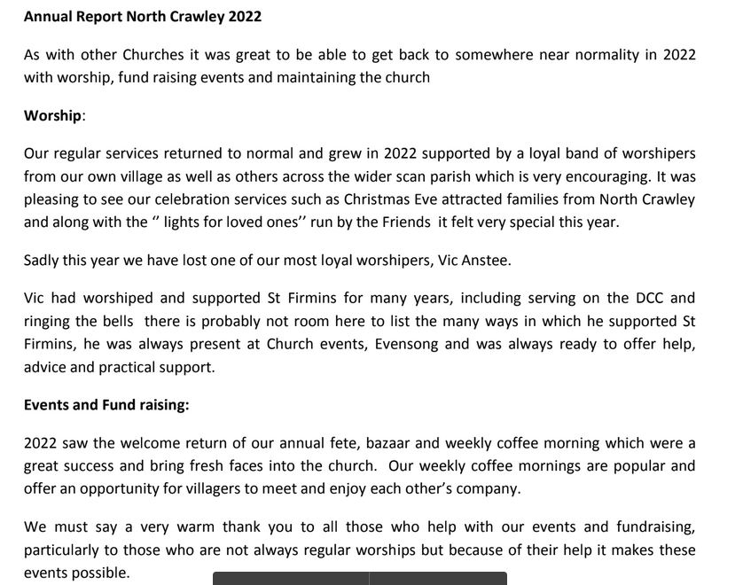

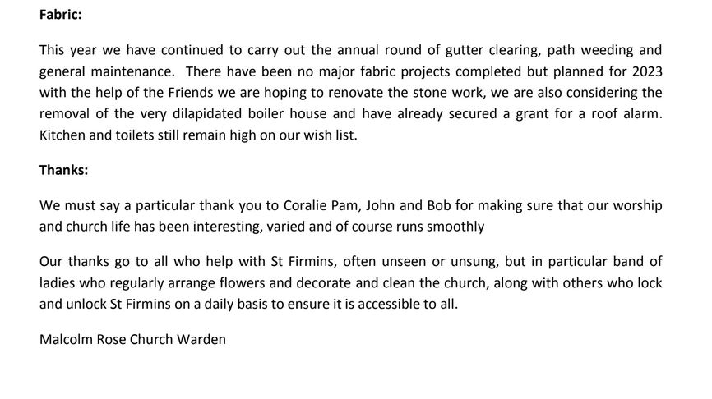

Financial Reports year ending 31st December 2021

SCAN PCC Treasurers report:

Accounts 1st. January to 31st. December 2022
A profit of £1062 has been achieved versus a Covid impacted loss of £266 last year.
Income
Parish Contributions were better than last year but do not reflect the full amount normally received pre Covid. However, in view of the fact that the PCC now receives 50% of the wedding fees (contra church income) contributions from the DCC's should be reduced and therefore need reviewing.
Gift Aided Donations have increased slightly owing to a new donor.
Other Donations are zero versus a one-off donation in 2021.
Wedding fees in 2022 only reflect the first 6 months: the last 6 months will appear in 2023.
The North Crawley toddlers group has disbanded, but note that a sum of £212 has been preserved in the Restricted Funds for the future.
Other Income has increased owing to the sale of equipment and increased interest from the deposit fund.
Expenditure
The Administrator's salary is lower than last year as it only reflects 8 months costs.
Travel expenses have been claimed for 2022 whereas expenses were not claimed last year owing to generous gestures by the clergy.
Hire of premises in 2022 were for the away day at the Mead centre and for Chicheley Village PCC meetings.
Church Licences are lower as the Streaming Plus licence was used last year to support on-line services, not required in2022.

 | SCAN PARISH PCC
 | INCOME & EXPENDITURE ACCOUNT
 | PERIOD | 1st. January to 31st. December
 |  |  |  |  |  | 2022 |  | 2021
 | INCOME
 |  | Parish contributions |  |  |  | 2000 |  | 1000
 |  | Gift aided donations |  |  |  | 1520 |  | 1250
 |  | Other donations |  |  |  | 0 |  | 150
 |  | Gift Aid tax refund |  |  |  | 313 |  | 250
 |  | Burial/wedding fees |  |  |  | 1291 |  | 1652
 |  | Donations NC Toddlers |  |  |  | 0 |  | 150
 |  | Other Income / Interest |  |  |  | 212 |  | 6
 |  |  |  |  |  | 5336 |  | 4458
 | EXPENDITURE
 |  | Administrator's salary |  |  |  | 1365 |  | 2830
 |  | Organist fees |  |  |  | 140 |  | 80
 |  | Travel expenses |  |  |  | 754 |  | 0
 |  | Hire of premises |  |  |  | 125 |  | 0
 |  | Books |  |  |  | 209 |  | 51
 |  | Stationery/postage/photocopying |  |  |  | 39 |  | 132
 |  | Church licences |  |  |  | 180 |  | 248
 |  | Church expenses |  |  |  | 38 |  | 39
 |  | Pastoral care |  |  |  | 0 |  | 0
 |  | NC Toddlers |  |  |  | 0 |  | 0
 |  | Astwood church insurance |  |  |  | 186 |  | 186
 |  | Charity donations |  |  |  | 550 |  | 550
 |  | Equipment |  |  |  | 32 |  | 211
 |  | Sundries |  |  |  | 656 |  | 397
 |  |  |  |  |  | 4274 |  | 4724
 | PROFIT / (LOSS) |  |  |  |  | 1062 |  | -266
 | NOTE - Sundries
 |  | Flowers for Jan Weatherly |  |  |  | 35 |  | 0
 |  | Employers liability insurance |  |  |  | 84 |  | 84
 |  | Condolence books |  |  |  | 0 |  | 313
 |  | Small Lottery Licence |  |  |  | 40 |  | 0
 |  | Black frames for HM Queen |  |  |  | 18 |  | 0
 |  | Commemoration OOS for HM Queen |  |  |  | 329 |  | 0
 |  | Crib cut-outs |  |  |  | 84 |  | 0
 |  | Choc. For NC & Sher. Schools |  |  |  | 66 |  | 0
 |  |  |  |  |  | 656 |  | 397
 | SCAN PARISH PCC
 | ACCUMULATED FUNDS AS AT 31st.DECEMBER
 |  |  |  |  |  | 2022 |  | 2021
 | Balance at 1st. January |  |  |  |  | 13630 |  | 13896
 | Excess income over expenditure |  |  |  |  | 1062 |  | -266
 | Balance at 31st. December |  |  |  |  | 14692 |  | 13630
 | Represented by:-
 |  | Santander (SME Club & Society A/C) |  |  |  | 3986 |  | 2995
 |  | Central Board of Finance |  |  |  | 10706 |  | 10635
 |  | (Church of England Deposit fund)
 |  |  |  |  |  | 14692 |  | 13630
 | Note
 | Santander (SME Club & Society A/C)
 |  | Ordinary Funds |  |  |  | 3368 |  | 2190
 |  | Restricted Funds Toddlers |  |  |  | 212 |  | 212
 |  | Restricted Funds Pastoral Care |  |  |  | 393 |  | 393
 |  | Restricted Funds Astwood Church |  |  |  | 13 |  | 200
 |  |  |  |  |  | 3986 |  | 2995
 |  | Examined and verified in accordance with the General Directions
 |  | given by the Charity Commission.
 |  | Signed:
 |  | Date:

Chicheley

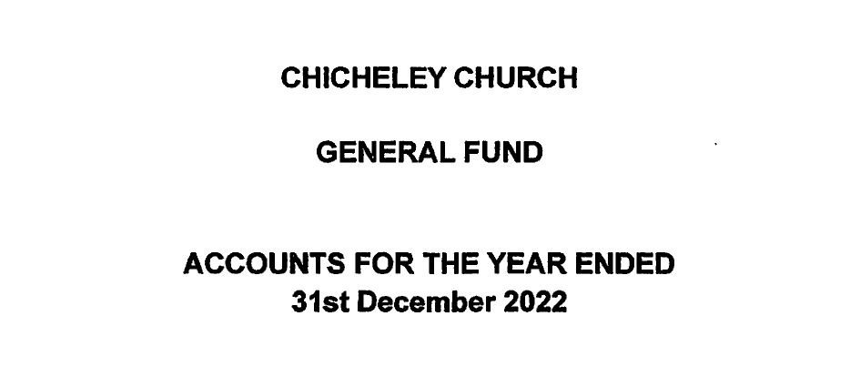

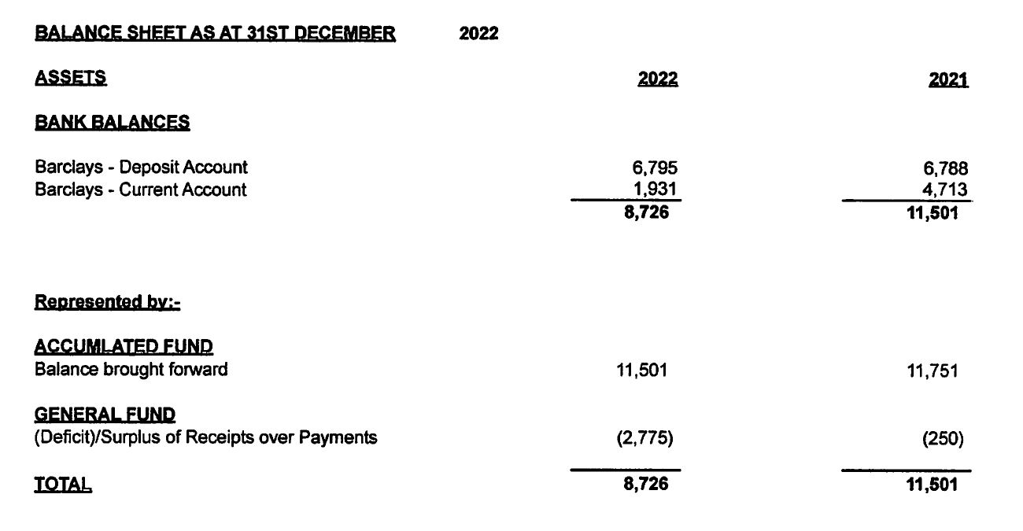

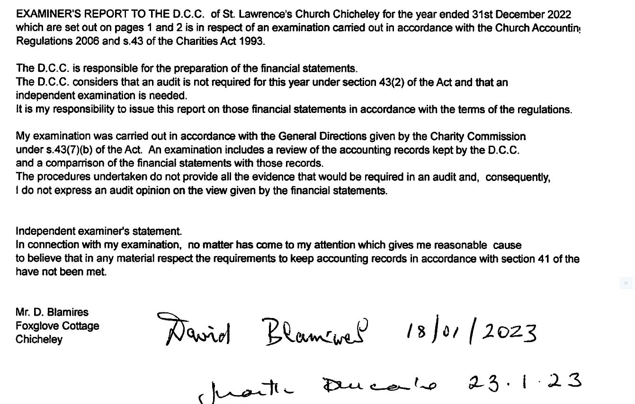

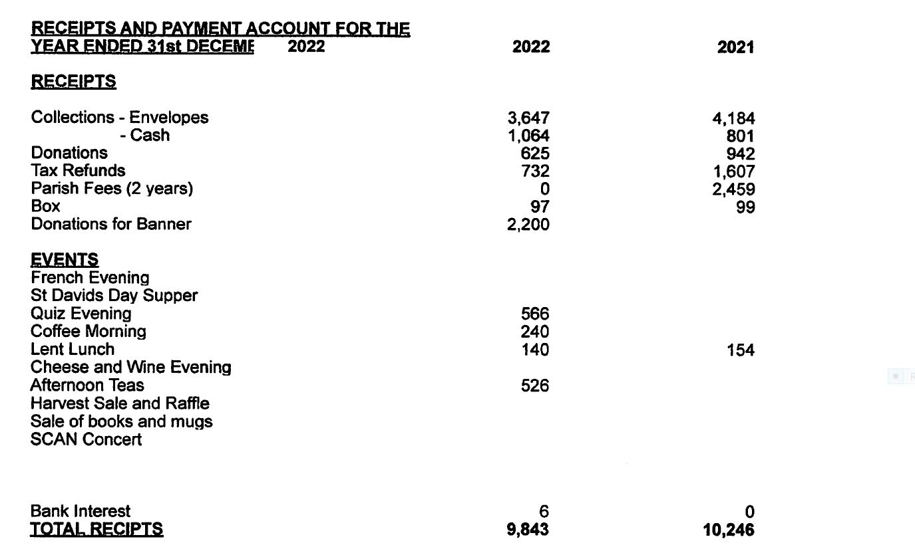

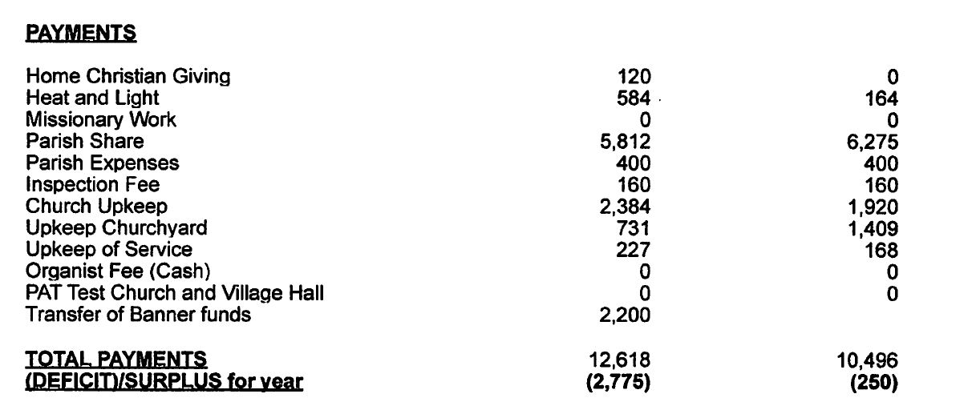

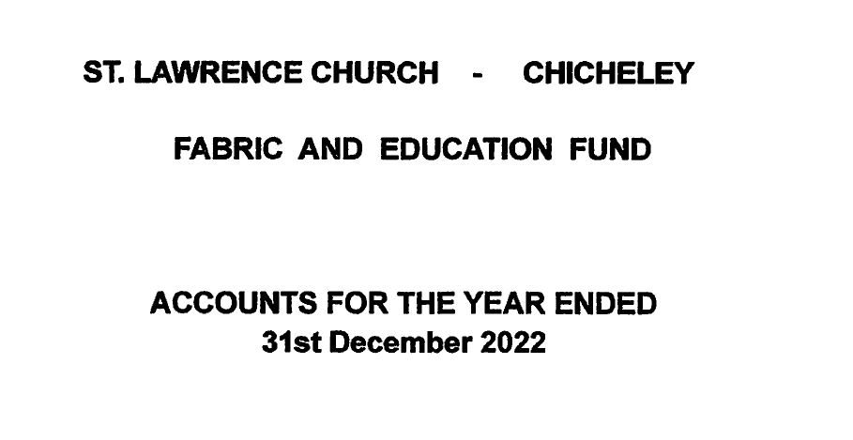

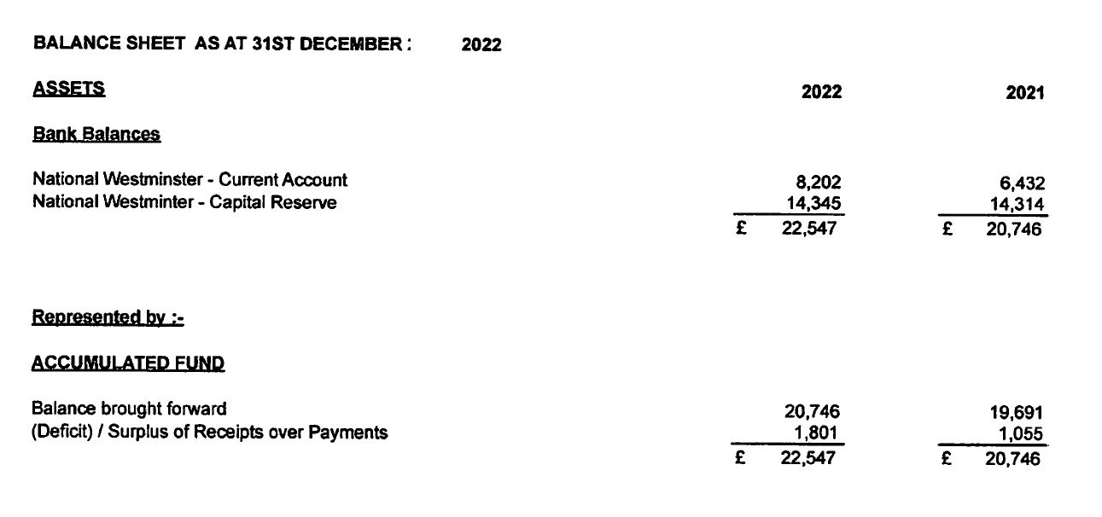

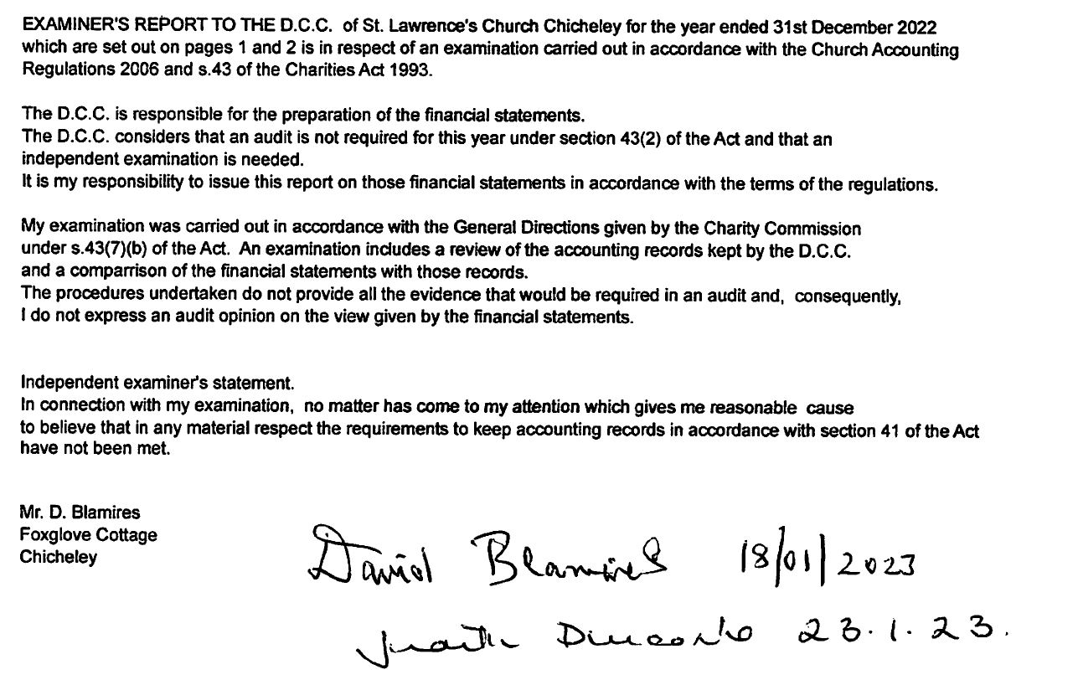

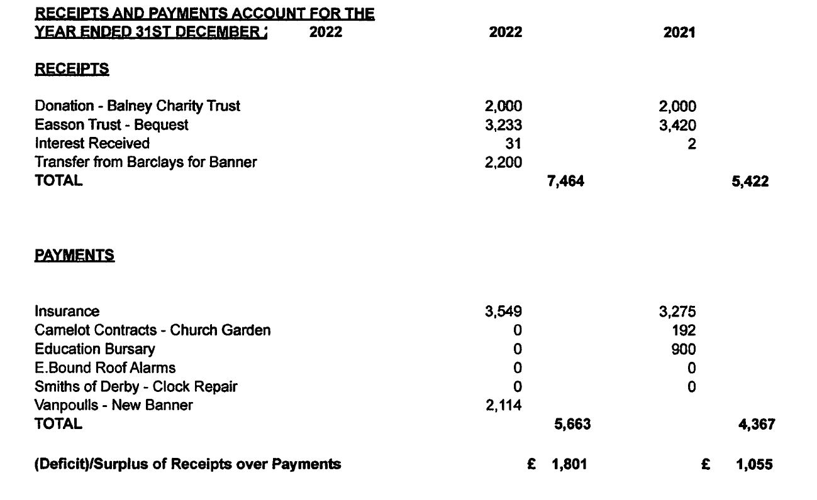

North Crawley

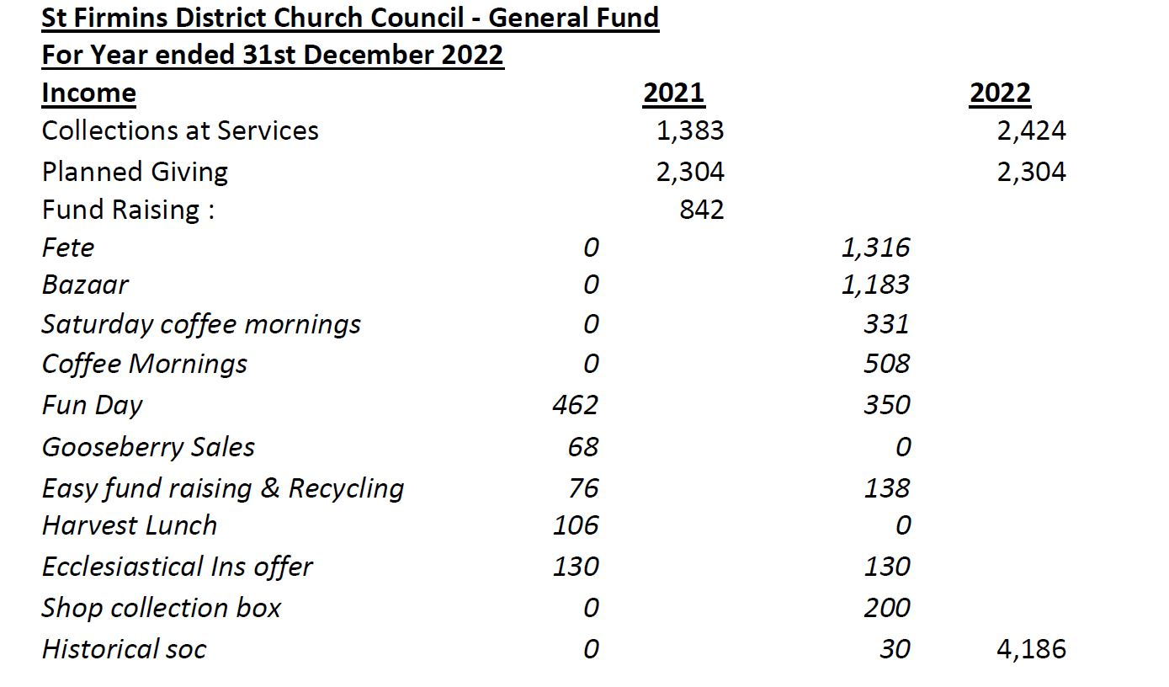
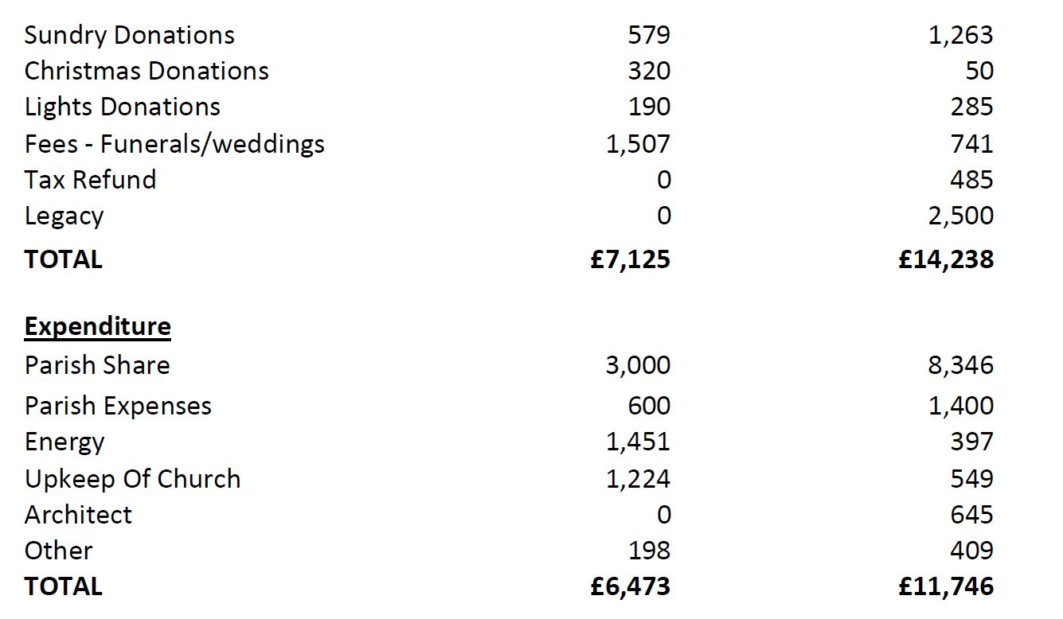

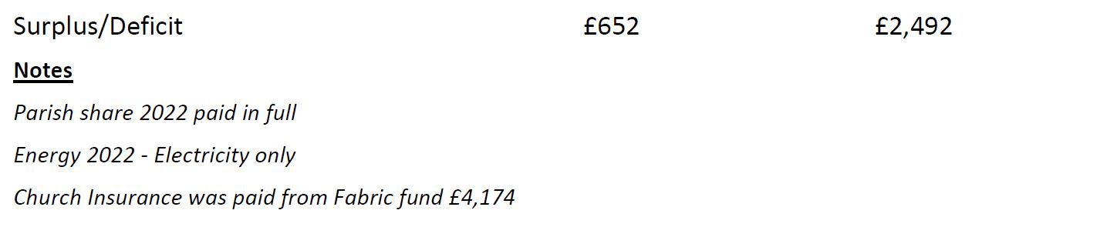

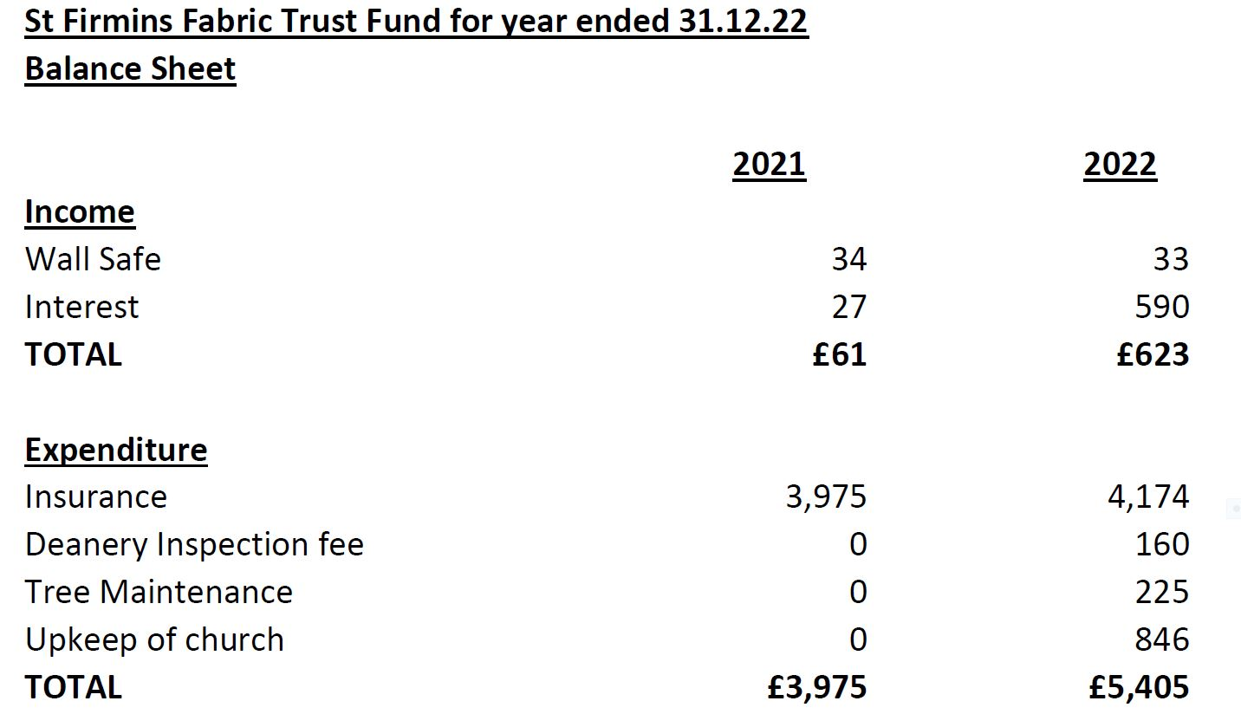

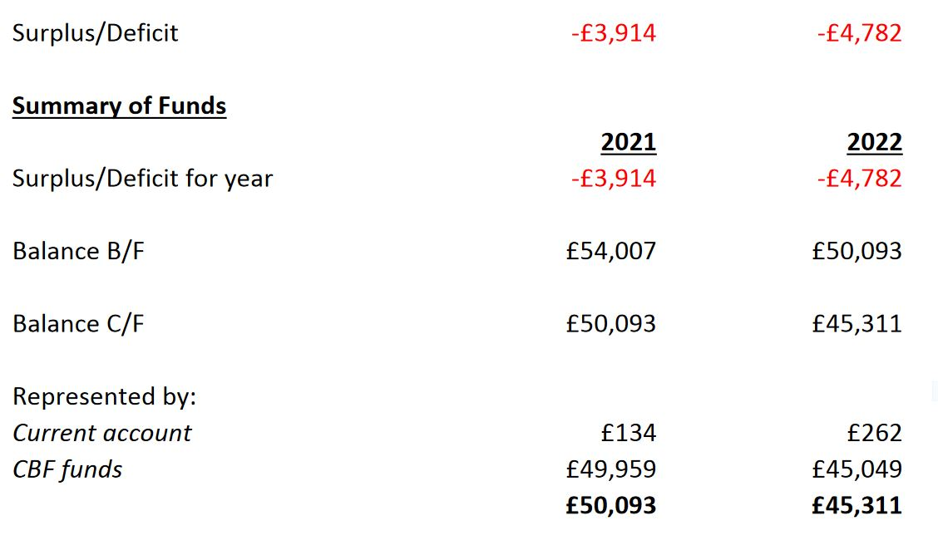

Sherington –

ANNUAL REPORT YEAR ENDING 31 st December 2022 St Laud’s Church Sherington

We opened 2022 with a General Account Balance of £ 17,207 and on 31 st December 2022 this
balance was £19,045. So there was a financial profit in the year of £1,838. This increase reflects the
timing of two major items for which we received income in 2022 but for which the costs are due to
occur in early 2023 (kitchen refurbishment £1300, church floodlighting £400). Underlying income
and expenditure were basically level and all income generated was utilised to meet our various cost
commitments.
Income in the year was £24,116, getting back to pre-Covid levels. This reflected income from
planned monthly donations and service collections, but also nearly a third was generated from
significant fundraising effort without which the financial picture would have looked very different
and which may be difficult to sustain to that level moving forwards. Expenditure was £ 22,279
including a £12,518 Parish Share payment to the Oxford Diocese.

Nigel Anderson
Treasurer St Laud’s Church
24.03.2023

